# Point of Failure for each algorithm

We used the test1.dps in estimating the point of failure for each algorithm. We pull the string, if the points is not in it’s normal order then the algorithm fail. We determined the point of failure by stepping manually then doing the mentioned tests. Our results is in the following table.

|  |  |  |
| --- | --- | --- |
|  | Time Step->Tension@(5) | Tension->Time Step@(0.01) |
| Euler | 0.1 | 12 |
| Mid point | 0.23 | 265 |
| huens | 0.2 | 990 |
| RK 4th | 0.2 | 7400 |
| RK 4th Adabtive | 0.25 | 28500 |
|  |  |  |

# Calculating the Error

We used the test1.dps in estimating the error. As this test start the particles moves in the y direction due to the force of gravity so we focus in our analysis on the y direction (the same as the gravity force).

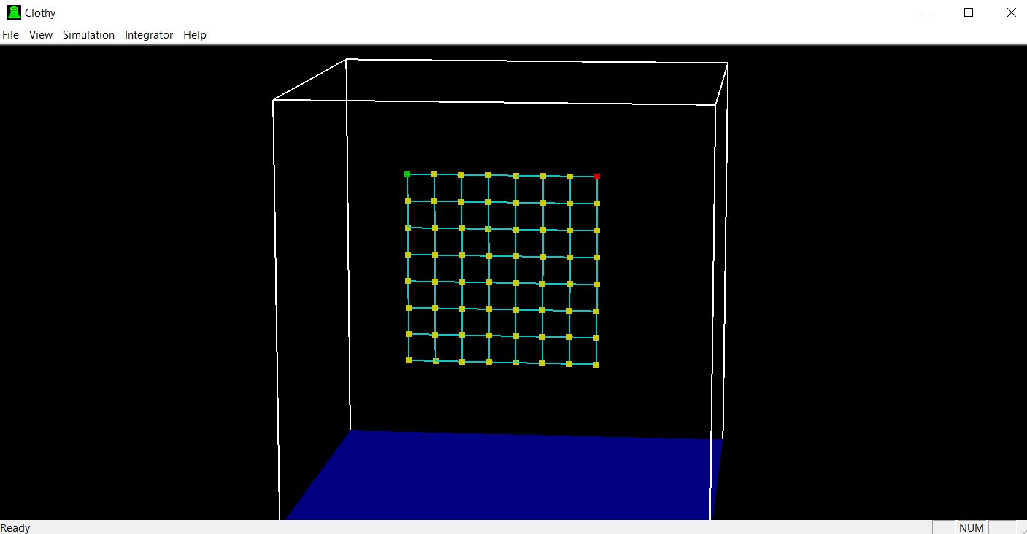

We pick our reference as the **RK 4th order** with **time step = 0.001**.

Our test samples of (time, Pos) is taken at **time step = 0.1**

We then draw the output of Each method against our reference **RK @ time Step=0.1** and w also calculate the absolute max error against the reference across all the samples that is taken at different times.

## Euler

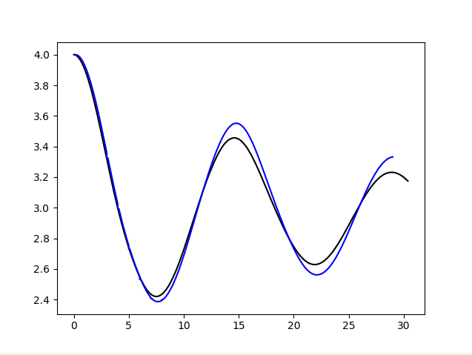 Max Error = 0.0435500000000002

## MidPoint

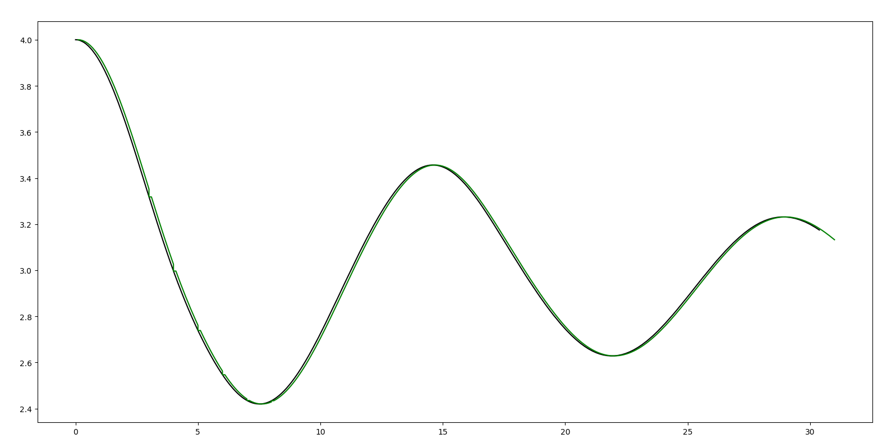

Max Error = 0.03406999999999982

## Huen’s

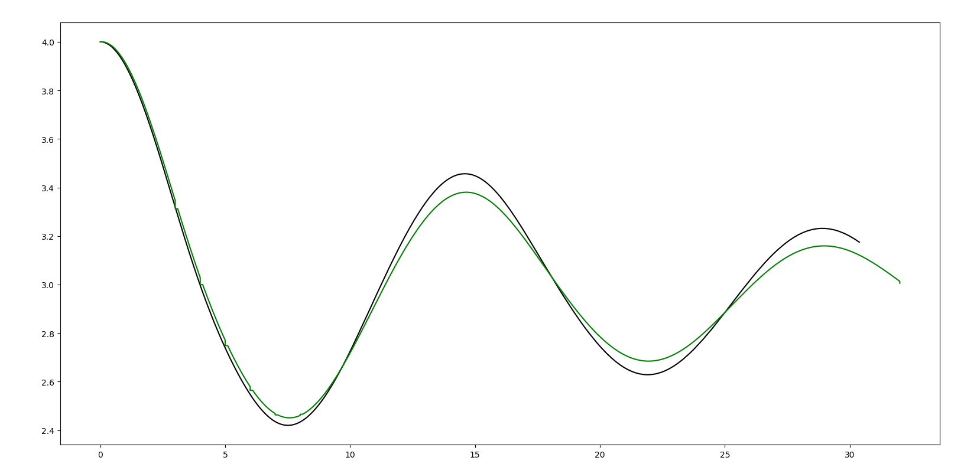

Max Error = 0.03205999999999998

## 

## RK 4th Order

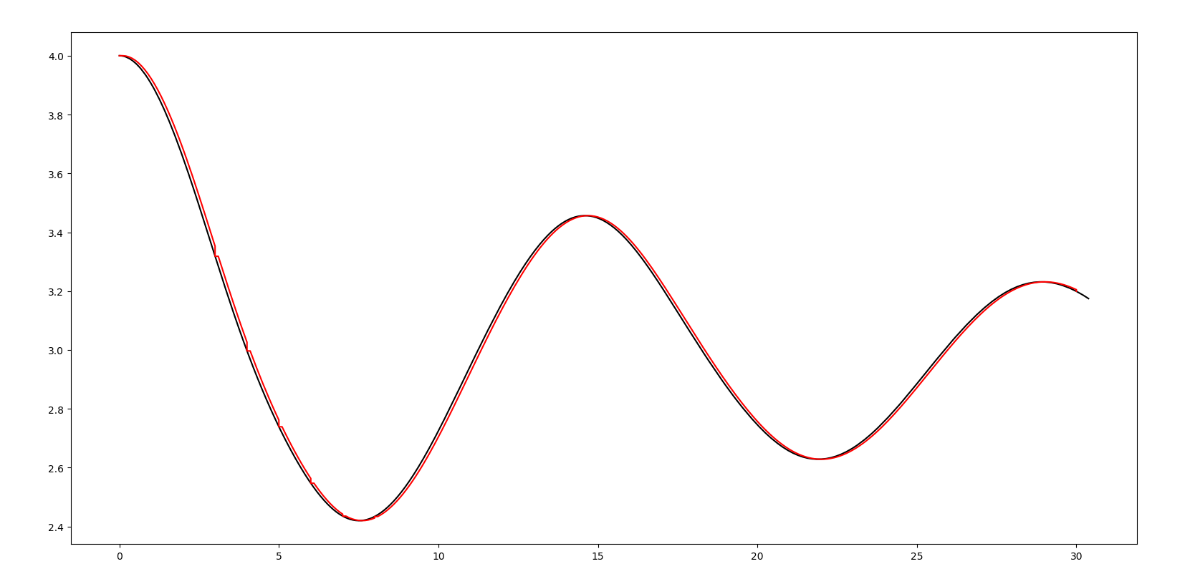

Max Error = 0.034259999999999735

## RK adaptive 4th Order

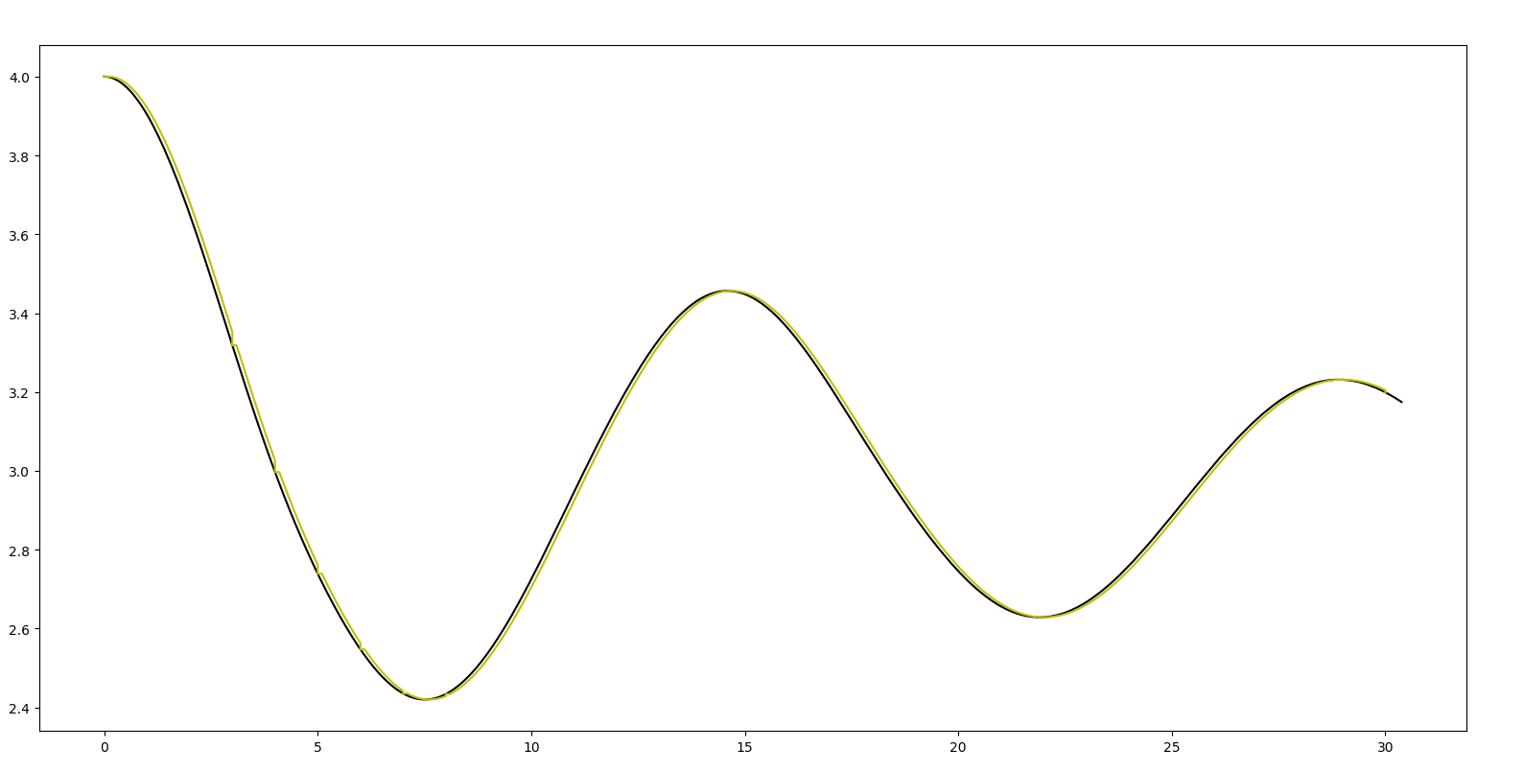

Max Error = 0.034259999999999735